**Lec09**

Quiz 3.3) The probability density function of the random variable *Y* is



Sketch the PDF and find the following:

1. the expected value 
2. the second moment 
3. the variance 
4. the standard deviation 



1. the expected value 



1. the second moment 



1. the variance 



1. the standard deviation 



Families of Continuous Random Variables

Uniform Random Variable









Exponential Random Variable

*X* is an exponential () random variable if the PDF of *X* is





If *X* is an exponential () random variable,







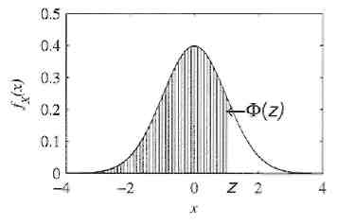

**Gaussian Random Variable**

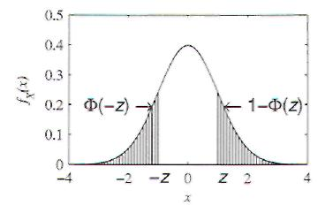

* Bell shaped curve
* Normal random variables  or Gaussian

If random variable  is Gaussian if the  of  is



Where  can be any real number and the parameter 







Sample code of above graph

mu = 0;

sigma = 1;

x = linspace(-5,5,100);

pdf = 1/sqrt(2*pi*sigma^2) *exp(-((x-mu).^2)/(2*sigma^2));

Properties: Linear transformation of Gaussian **r.v** produces another Gaussian r.v.

If  is Gaussian,  is Gaussian

Standard Normal Random Variable: Gaussian (0, 1)



The CDF of the standard normal r.v. is defined as (Note: “*randn*” in Matlab)



Now the CDF is defined as



The probability that  is in the interval  is



Let , then 



The symmetry property of Gaussian function is



Ex) If  is the Gaussian (61, 10) or  random variable, what is?



Let’s plug in given values to the equation, 



Since there is no  value in the chart, we need to find 1- values.

Now we know that, the value of



In this case, it is true that  = 

Standard normal complementary CDF



Quiz 3.5) is Gaussian (0, 1) random variable and  is the Gaussian (0, 2) random variable.

1. Sketch the PDFs of both
2. What is 
3. What is 
4. What is 
5. What is 

b) 0.6286

c) 0.383

d) 

e) 0.0401



